**Create database -> sales**

1. **Table name - > SALES_PERSON**

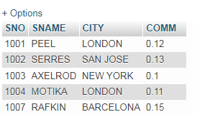

1. **Table name - > CUSTOMER**

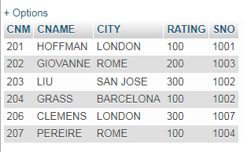

1. **Table name - > ORDERS**

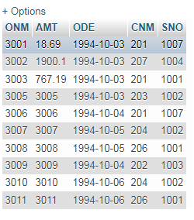

1. All order form more then $1000.

Ans=> SELECT * FROM orders WHERE AMT>1000;

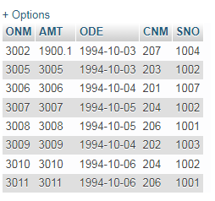

1. Names and citis of all salespeople London with commission abouve 0.10.

Ans=> SELECT SNAME,CITY FROM sales_person WHERE COMM>0.10;

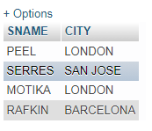

1. All salespeople either in Barcelona or in londone.

Ans=> SELECT * FROM sales_person WHERE CITY='BARCELONA' OR CITY='LONDON';

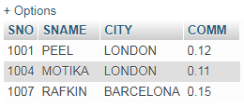

1. All salespeople with commition between 0.10 and 0.12(Boundary values should be excluded)

Ans=> SELECT * FROM sales_person WHERE COMM BETWEEN 0.10 AND 0.12;

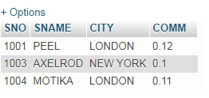

1. All customer with NULL values in city column.

Ans=> SELECT * FROM customer WHERE CITY='NULL';

Not available NULL values in This table.



1. All order takes on Oct 3Rd and Oct 4th 1994.

Ans=> SELECT * FROM orders WHERE ODE BETWEEN '1994-10-03' AND '1994-10-04';

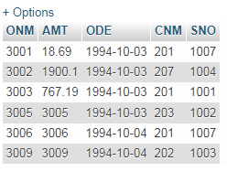

1. All customers serviced by peel or motika.

Ans=>

1. All customer whose names begin with latter from A to B.

Ans=> SELECT * FROM customer WHERE CNAME LIKE'A%' OR CNAME LIKE 'B%';

Not Available begin latter with ‘A’ to ‘B’



1. All customer excluding those with rating <= 100 unless they are located in Rome.

Ans=> SELECT * FROM customer WHERE RATING<=100 AND CITY='ROME';

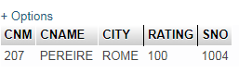

1. All order except those with 0 or NULL value in amt field.

Ans=> SELECT * FROM orders WHERE AMT!=0 AND AMT IS NOT null;

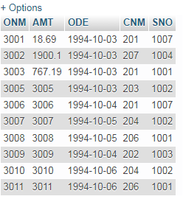

1. Count the number of salespeople current listing order in the order table.

And=>